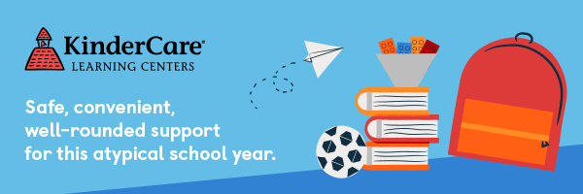

If your big kid needs support during this atypical school year, our programs for kids in grades K-6 are here for you! We have partnered with U-46 local schools to complement the learning they offer with our own robust curriculum for elementary schoolers including project-based STEM learning activities, art, outdoor play, homework support, and more.

We’ve built three key components into our program to take extra-special care of the hearts and minds of every student as we navigate the pandemic:

1. **WARM WELCOME**     
   Kids are social creatures! This long stretch of isolation can stir up big feelings, and kids need dedicated space and help from grown-ups to process. We’ll spend time each day, checking in and building community, trust, and connection with one another. We support a positive, anti-bias classroom culture through student-centered class meetings, social emotional learning activities, and daily mindfulness practice.
2. **STUDENT CHOICE**    
   Kids love learning even more when they can choose what they’re learning about! We’ve all experienced a huge loss of control this year—but in our classrooms, children have choices! Our student-led learning approach allows big kids to make decisions, explore personal interests, and share feedback with their peers. **This school year, we’re helping students define their own projects to build resilience through five themes: problem-solving, optimism, empathy, growth mindset, and creativity.**
3. **ACADEMIC SUPPORT**    
   Our teachers understand that every family will manage their children’s learning needs in the way that works best for them—and no two families are the same. Flexibility is built into our program, so you can get the support you need, when you need it.

 To prioritize safety, we use a small-group Pod structure to keep kids with the same group of peers and educators every day. Of course, there’s much more we’re doing to protect our community, and I invite you to [learn more about the industry-leading health and safety practices](https://www.kindercare.com/lp/safety-first) that make our center one the safest places your child can be.

If you have any questions about our big-kid program, how we’re keeping families safe, or if you’re ready to enroll for the new school year, I’d be happy to help!

Kind Regards,

Wendy Mendoza

South Elgin Spring St. KinderCare

847-289-5280